**Funding Circle-**

**Bagging:**

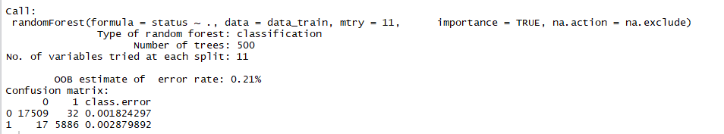

Confusion matrix and accuracy-

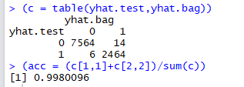

Variable importance-

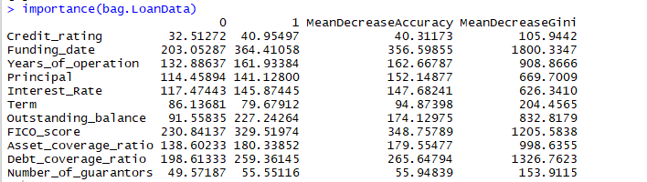

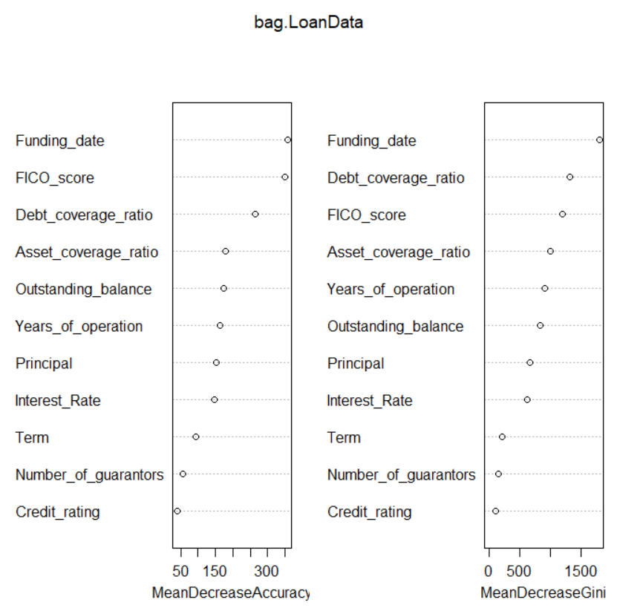

**Random Forest:**

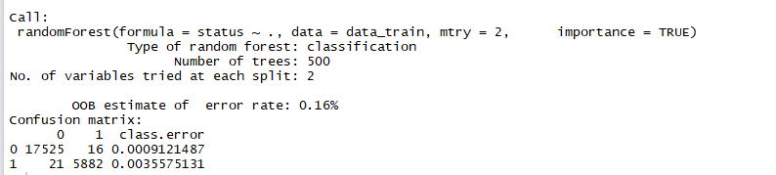

Confusion matrix and accuracy-

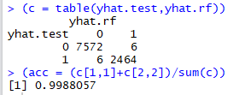

Variable Importance-

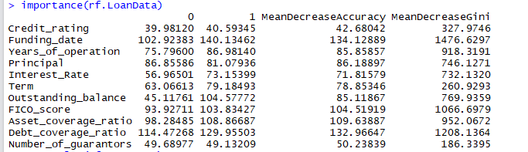

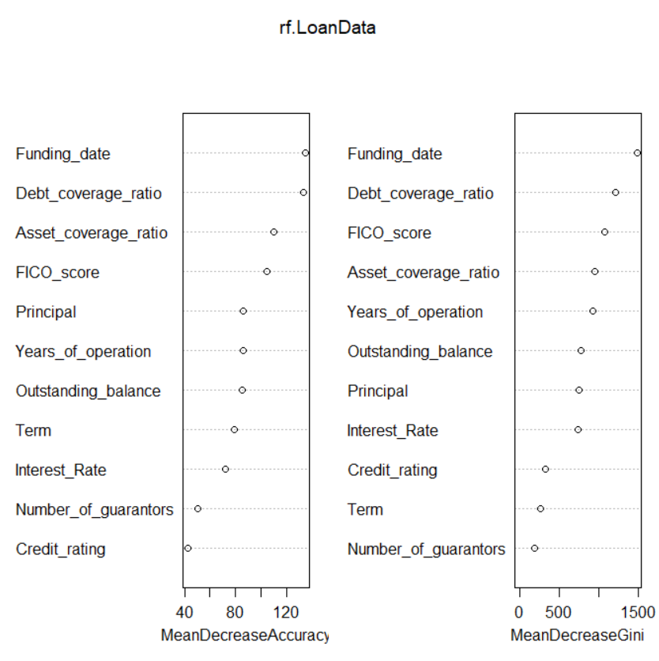

**Boosting:**

Relative influence-

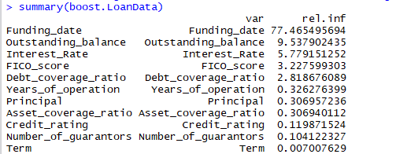

Confusion matrix and accuracy-

